**EXPLORATION OF MUSHROOM**

Exploring mushrooms by its different characteristics & identifiable features below:

* **Cap-colour:** *The cap is the top of the mushroom (and often looks sort of like a small umbrella). Mushroom caps can come in a variety of colours.*

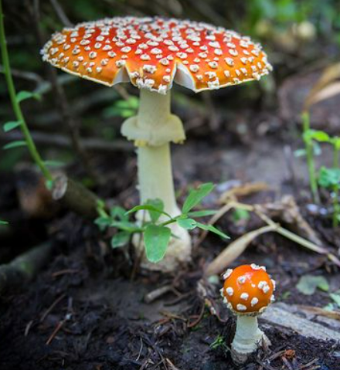 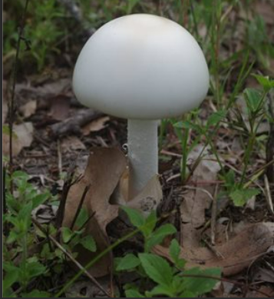

**Red Cap-Coloured Mushroom White Cap-Coloured Mushroom**

* **Cap-shaped:** *The shape of top portion of mushroom.*

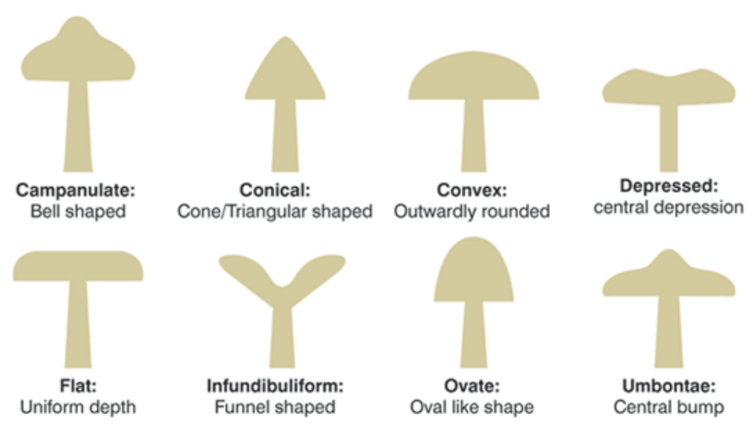 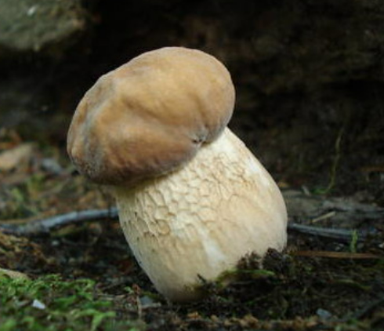

**Different shapes of Mushrooms Knobbed shaped mushroom**

* **Veil:** *A veil is one of several structures in fungi, especially the thin membrane that covers the cap and stalk of an immature mushroom.*

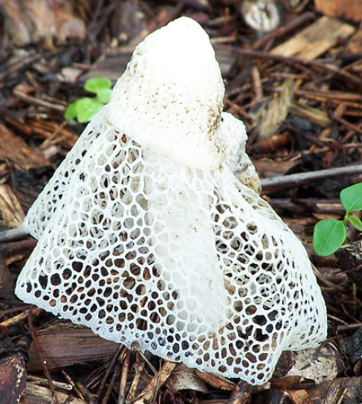 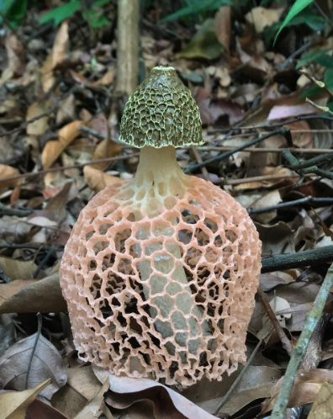

**Full body covered with white colour veil Partial body covered orange coloured veil**

* **Bruise:** *A bruise is a common skin injury that results in a discoloration of the skin.*

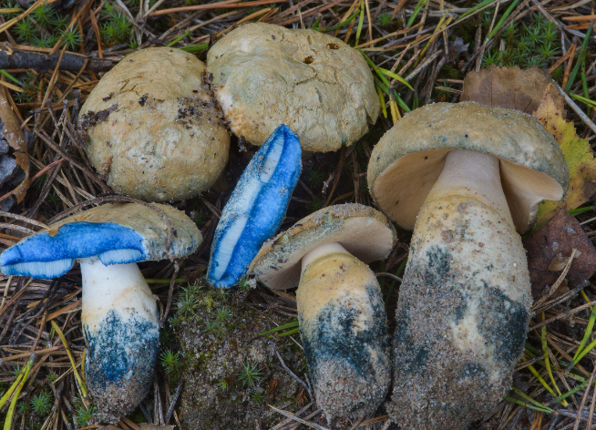 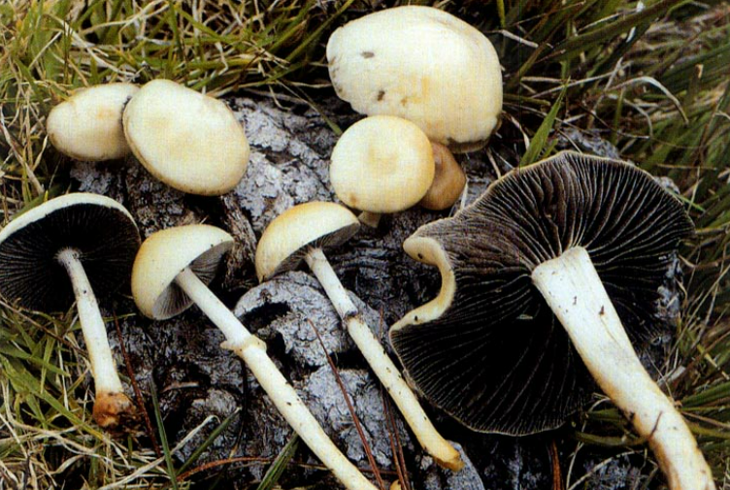

**Bruised (Discoloration of mushroom) Non-Bruised Mushroom**

* **Habitat & Population:** *A population is all of one kind of species residing in a particular location. Habitat is usual or preferred surroundings of any species. Population size represents the total number of individuals in a habitat.*

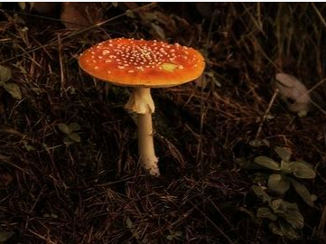 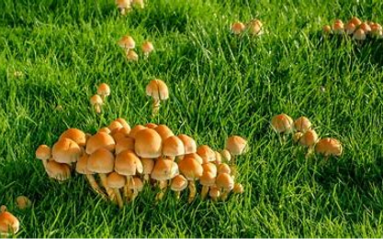

**Solitary mushroom grown in leaves habitat Numerous or abundant mushroom in green habitat**

* **Gill size:** *These structures appear under the mushroom’s cap.*

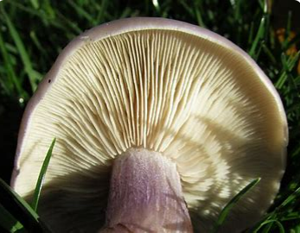 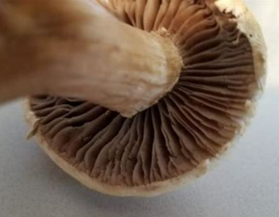

**Narrow size & buff coloured gills** **Broad size & brown coloured gills**